Lab#8 Create a responsive web page of your college which includes information regarding Vision, Mission, Program specific outcomes, Courses Offered, Image gallery of events, Top Recruiters using Bootstrap only.

TAGS USED | DESCRIPTION
<!DOCTYPE HTML> | DECLARES THE DOCUMENT AS AN HTML5 DOCUMENT.
<HTML> | ROOT ELEMENT OF THE HTML DOCUMENT.
<HEAD> | CONTAINS METADATA AND INFORMATION ABOUT THE HTML DOCUMENT.
<META> | DEFINES METADATA FOR THE HTML DOCUMENT.
<LINK> | LINKS AN EXTERNAL CSS FILE TO THE HTML DOCUMENT.
<TITLE> | SPECIFIES THE TITLE SHOWN IN THE BROWSER TAB.
<BODY> | CONTAINS ALL VISIBLE CONTENT OF THE WEBPAGE.
<HEADER> | DEFINES THE HEADER SECTION OF THE WEBPAGE.
<H1> | DEFINES THE MAIN HEADING.
<H2> | DEFINES A SECONDARY HEADING.
<NAV> | DEFINES THE NAVIGATION SECTION.
<A> | DEFINES HYPERLINKS TO DIFFERENT SECTIONS OF THE WEBPAGE.
<MAIN> | DEFINES THE MAIN CONTENT OF THE WEBPAGE.
<SECTION> | DEFINES SEPARATE SECTIONS OF CONTENT.
<H3> | DEFINES SECTION HEADINGS.
<P> | DEFINES A PARAGRAPH.
<UL> | DEFINES AN UNORDERED (BULLETED) LIST.
<OL> | DEFINES AN ORDERED (NUMBERED) LIST.
<LI> | DEFINES AN ITEM IN A LIST.
<FOOTER> | DEFINES THE FOOTER SECTION OF THE WEBPAGE.

Final Outcome:

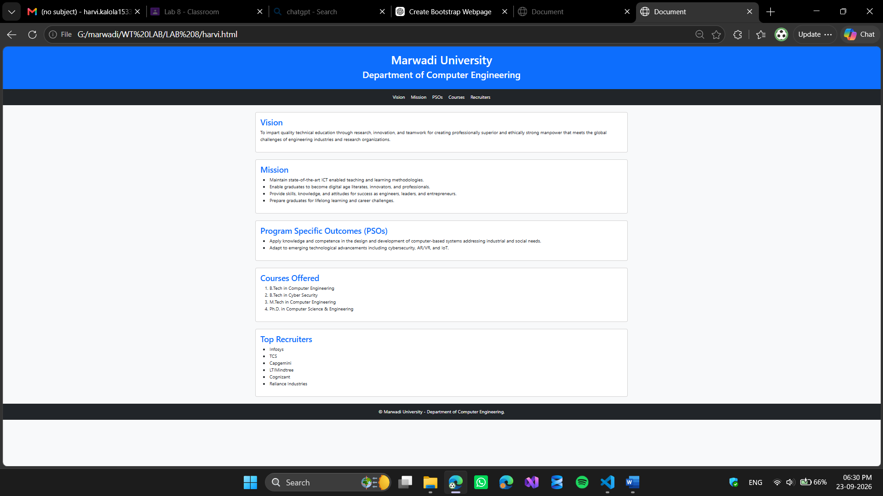

Code Snippet:

<!DOCTYPE html>
<html lang="en">
<head>
<meta charset="UTF-8">
<meta name="viewport" content="width=device-width, initial-scale=1.0">

<link href="https://cdn.jsdelivr.net/npm/bootstrap@5.3.3/dist/css/bootstrap.min.css" rel="stylesheet">

<title>Document</title>

<style>
.nav-link:hover {
background-color: #e2fbfc;
color: #03222d !important;
text-decoration: underline;
}
</style>
</head>

<body class="bg-light">

<header class="bg-primary text-white text-center p-4">
<h1>Marwadi University</h1>
<h2>Department of Computer Engineering</h2>
</header>

<nav class="bg-dark text-center p-3">
<a href="#vision" class="nav-link d-inline-block text-white mx-2">Vision</a>
<a href="#mission" class="nav-link d-inline-block text-white mx-2">Mission</a>
<a href="#pso" class="nav-link d-inline-block text-white mx-2">PSOs</a>
<a href="#courses" class="nav-link d-inline-block text-white mx-2">Courses</a>
<a href="#recruiters" class="nav-link d-inline-block text-white mx-2">Recruiters</a>
</nav>

<main class="container my-4">

<section id="vision" class="card mb-4">
<div class="card-body">
<h3 class="text-primary">Vision</h3>
<p>
To impart quality technical education through research,
innovation, and teamwork for creating professionally superior
and ethically strong manpower that meets the global challenges
of engineering industries and research organizations.
</p>
</div>
</section>

<section id="mission" class="card mb-4">
<div class="card-body">
<h3 class="text-primary">Mission</h3>
<ul>
<li>Maintain state-of-the-art ICT enabled teaching and learning methodologies.</li>
<li>Enable graduates to become digital age literates, innovators, and professionals.</li>
<li>Provide skills, knowledge, and attitudes for success as engineers, leaders, and entrepreneurs.</li>
<li>Prepare graduates for lifelong learning and career challenges.</li>
</ul>
</div>
</section>

<section id="pso" class="card mb-4">
<div class="card-body">
<h3 class="text-primary">Program Specific Outcomes (PSOs)</h3>
<ul>
<li>Apply knowledge and competence in the design and development of computer-based systems addressing industrial and social needs.</li>
<li>Adapt to emerging technological advancements including cybersecurity, AR/VR, and IoT.</li>
</ul>
</div>
</section>

<section id="courses" class="card mb-4">
<div class="card-body">
<h3 class="text-primary">Courses Offered</h3>
<ol>
<li>B.Tech in Computer Engineering</li>
<li>B.Tech in Cyber Security</li>
<li>M.Tech in Computer Engineering</li>
<li>Ph.D. in Computer Science & Engineering</li>
</ol>
</div>
</section>

<section id="recruiters" class="card mb-4">
<div class="card-body">
<h3 class="text-primary">Top Recruiters</h3>
<ul>
<li>Infosys</li>
<li>TCS</li>
<li>Capgemini</li>
<li>LTIMindtree</li>
<li>Cognizant</li>
<li>Reliance Industries</li>
</ul>
</div>
</section>

</main>

<footer class="bg-dark text-white text-center p-3">
&copy; Marwadi University - Department of Computer Engineering.
</footer>

</body>
</html>

